A Case of Mistaken Identity

On the 24 January 2025 a tiny artefact was sold at auction. It was only 1.8cm in length, but its historical importance made up for its miniscule size. Made of rock crystal with a gold top, the artistry was impressive, especially when taking into consideration of the skill the craftsman would have needed to create the intricate design. The piece was simply labelled as a rock crystal seal. However, what was this piece, and who had owned such an item? The auction house identified it as belonging to Queen Mary I, the daughter of Henry VIII and Catherine of Aragon, England’s first crowned Queen Regnant. However, it may also have been owned by a member of her close circle of servants and council who conducted her business on her behalf. The signet stamp was a device used to authenticate state papers without the monarch’s signature. The significance of such a stamp meant that only the monarch herself or someone she trusted in a position of power would have owned such a thing.
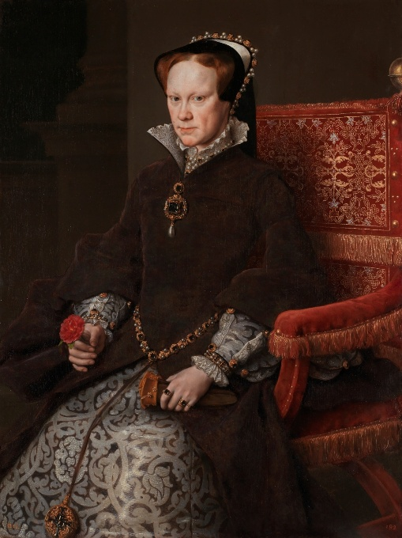
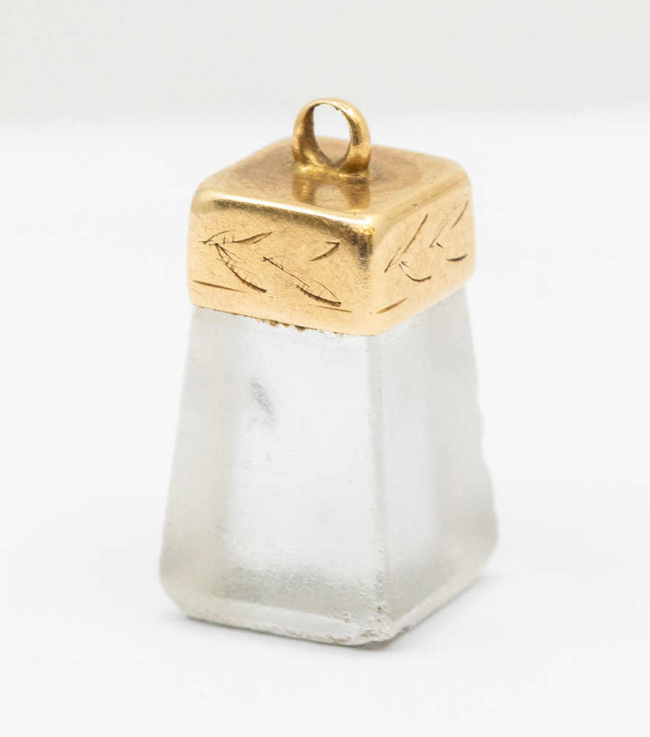

Figure 1 Signet stamp
Figure 2 Mary I by Anthonis Mor (1554) © Wikicommons

Within government there were nine Seals used for administration. The word Seal comes from the Latin Sigilla which derives from signum, meaning a mark or sign. Out the Seals of Estate, the most famous is the Great Seal which was required for any state document. It was the embodiment of the Crown and was in possession of the Lord Chancellor. Yet, if the monarch was on progress, they could use a Privy Seal, first employed by King John, to authenticate or instruct the Great Seal.
Under the early Plantagenets, the Privy Seal was under the custody of the Keeper of the Wardrobe which evolved into the Keeper of the Privy Seal. By 1312, the Barons fearful of abuse by the Seal ensured that the Privy Seal clerk was appointed by the monarch in Parliament and approved by them. The Privy Seal office became a clearinghouse for official documents. Eventually, almost all non-judicial documents required a warrant from the Privy Seal before it could pass under the Great Seal.
Edward II, frustrated with the tiresome process of Parliamentary bureaucracy, started using a secret seal which evolved as the Signet. This was the king’s personal Seal and was guarded by his Secretary. It was a more direct way of implementing business without having to deal without the tedious nature of government. In his early years, Edward’s great grandson Richard II would use the Signet to ensure business was conducted quickly and its use put pressure on the Privy Seal to then inform the Great Seal to authenticate the document.
However, in 1383, Richard (as the tyrant he was) decided he could bypass the usual procedures and began using his Signet ring for everything which meant circumventing the Privy Seal office. The king communicated instructions directly to the Chancery. The Barons interpreted Richard’s “abuse” of the Signet as an attempt to take personal charge of government affairs and rule without Parliament. However, in 1386 Parliament fought back and ordered the reorganization of Richard’s administration and impeached Michael de la Pole, the King’s friend and Chancellor. Richard was forced to stop issuing Signet letters “to the damage of the Realm”, and his use of the Signet dramatically reduced.
Despite this episode, the Signet Seal continued to be used by English monarchs as personal approval for state documents and for administration. Only the monarch would have used such a device to authenticate the documents which passed through their hands. The significance of such a piece meant that upon the monarch’s death such legal appliances were to be destroyed to ensure fraud could not occur. Bearing this in mind, the survival of this Signet stamp is unheard of and such a piece must have been treasured by a loyal subject who had either been given the item or pocketed it before it could be destroyed.
Though a remarkable object, upon examination this seal produced more questions than answers. If this was Mary I’s seal then why did the coat of arms engraved not match with the English coat of arms seen in Mary’s other seals which consisted of the English Lions, The French Fleur de Lys between 1553-1554. Her coat of arms were then fused with Philip II’s upon their marriage in July 1554. This new coat of arms included Mary’s impaling Philip’s. When we examine this signet, the coat of arms includes the Scottish Rampant lion. With this inclusion and the monogram MR, the possible answer being, it was not Mary I’s, but another queen bearing the same name.
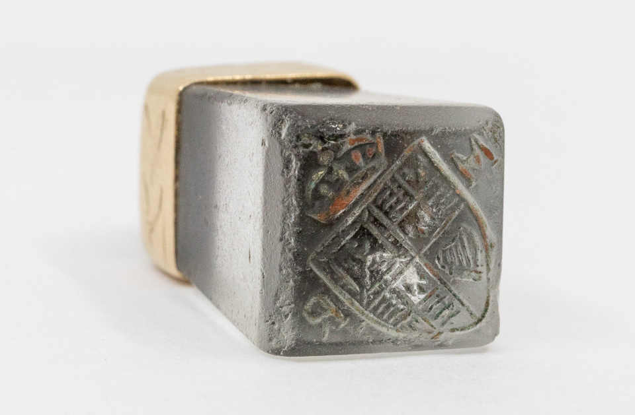

Figure 3 Mary's coat of arms

By examining the coat of arms there can only be one candidate. This seal stamp belonged to Mary II, England’s third queen regnant. Born 30 April 1662 as the daughter of James Duke of York, it had never been expected that she would one day wear the Crown. Her uncle Charles II was still alive and was expected to sire an heir. If he was to fail then Mary’s father would become king and there was hope he would have a son. Brought up Protestant she became a prize for European diplomacy. In November 1677 she married her cousin William of Orange, who ruled the Netherlands. It was there where she believed she would stay as William’s wife. However, God had other plans.
On 6 February 1685 Mary’s uncle Charles II, died with no legitimate heir to succeed him. The Crown was inherited by his brother James Duke of York and became James II/VII; England’s last Catholic monarch. Though unopposed as king, he soon became distrustful of his subjects after two failed rebellions by his illegitimate nephew the duke of Monmouth and the duke of Argyll in the Summer of 1685. James’ switch from tolerant king to one who favoured his Catholic subjects over long standing Protestant allies soon became a national discussion.
Though seen as a threat by his Protestant subjects, his lack of a male heir allowed parliament to accept that order would be restored upon his death. However, on 10 June 1687 the queen, Mary of Modena gave birth to a son. James’ Protestant subjects feared the worst and thought this child had been smuggled into the palace in a warming pan and a stillborn infant smuggled out by the same means. This rumour has no evidence, but to prevent a Catholic succession six senior English nobles and a bishop petitioned William to land with an army oust his father-in-law in a letter dated 30 June 1688. On 5 November 1689 Willaim arrived in England; though James had sought to fight, his officers abandoned him and even his own daughter Anne defected! As a result, James fled with his heart shattered. It was later said that he threw the Great Seal into the Thames. By this act he had abdicated.
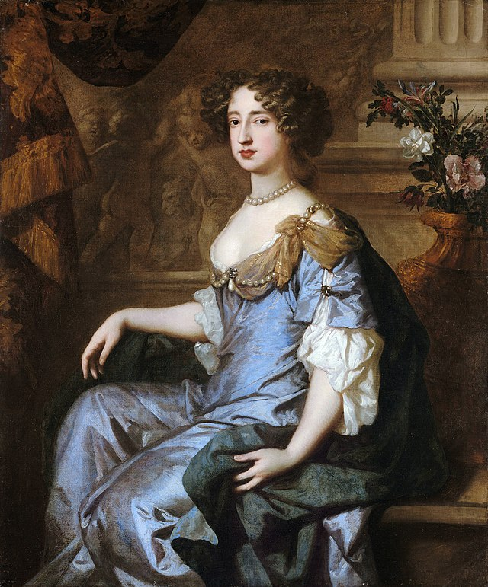

Figure 4 Mary II by Peter Lely (1662) © wikicommons

As the eldest daughter of the deposed James II, Mary was the legitimacy behind William’s invitation and was asked to rule by herself, by Thomas Osbourne, earl of Danby, but she refused. The compromise was for her to rule jointly with her husband, William, who became William III as a joint monarch. William’s mother was Mary Stuart, Princess Royal, daughter of Charles I making him Queen Mary’s first cousin. This event led to the Convention Parliament issued a Declaration of Rights on 12 February. The declaration was later embodied into the Bill of Rights passed by Parliament in December 1689 which stipulated that the throne could only be occupied by a Protestant. This was the beginning of Britian’s modern constitutional monarchy.
After their coronation on 11 April 1689 the King and Queen split their roles; William focused on military campaigns and foreign policy, while Mary took control of government administration. Though now a queen in her own right she was not comfortable with her new standing and sought enjoyment through her interest in horticulture and interior design. Their imagery cemented the partnership. In coinage and on the Great Seal, both William and Mary were presented. William was given the dominant position which did seem to relegate Mary as a junior partner, despite the political reality. Her main burden was the lack of an heir and the estrangement from her father. Though she had assisted in his overthrow, she could never forgive herself for betraying her once loving father.
This Seal Stamp is evidence that the queen was far more interested than once believed since the Signet Seal was the one prerogative a monarch had to issue their will on a personal level. Not only are the queen’s initials present MR, but Mary’s personal coat of arms followed her Stuart forebears after James I/VI united the crowns in 1603. The new heraldry depicted this union. The English lions and fleur de lys represented England, the harp Ireland and the rampant lion Scotland. This heraldry would later be used by Mary’s successor Anne until her own death in 1714.
By having this survival signet stamp, with the correct heraldry being identified, we know this item can be dated from 1689 until Mary’s untimely death in 1694 aged just thirty-two.
Though this seal is not Mary I’s, both Mary’s are linked through not only their common ancestry via Henry VII and Elizabeth of York, but their shared first name, they were both part of a dual monarchy, and both only ruled for five years.
